
Sharif College of Engineering & Technology
Computer Science Department
 | Day |  |  |  | Month |  |  | Year
DATE |  |  |  | _ |  |  |  |  | _

PROJECT TITLE | Intelligent Document Retrieval and Question Answering System using On-Premise AI and Retrieval-Augmented Generation
KEY WORDS | Document AI, Question Answering, Retrieval-Augmented Generation, OCR, NLP, Information Retrieval, On-Premise AI, Document Management, Vector Embeddings, Secure Document Processing
DOMAIN OF THE PROJECT | Artificial Intelligence, Natural Language Processing, Information Retrieval Systems
SUPERVISOR | Mam Hirra Mustafa
CO-SUPERVISOR | Dr Mazhar Iqbal

STUDENT INFORMATION
Sr. | Student ID | Name | Email
1. | UET-SHCET-LHR-CS-02 | AMNA IKRAM | Ikramamna980@gmail.com
2. | UET-SHCET-LHR-CS-12 | ZAIN UL HASSAN | Zainulhassan4330@gmail.com
3. | UET-SHCET-LHR-CS-13 | EZZA ANSAR | Ezzaansar05@gmail.com
Table of Contents
1. PROBLEM STATEMENT 3
2. EXECUTIVE SUMMARY 3
3. INTRODUCTION 4
4. COMPETITORS/COMPETITIVE ANALYSIS 5
4.1 4.1 Competitors 5
4.2 4.2 Our Competitive Edge 5
5. OBJECTIVES 5
6. MOTIVATION 6
7. FEATURES OF PROJECT 6
8. ARCHITECTURAL DESIGN 8
8.1 Hardware Components 8
8.2 Software Components 8
8.3 Network Components 8
8.4 System Architecture 9
9. IMPLEMENTATION TOOLS AND TECHNIQUES 9
9.1 Implementation Methodology 10
9.2 Implementation Tools 10
9.3 Development Approach 11
10. PROJECT PLAN 11
10.1. Division of Responsibilities 11
10.2. Project Timeline 12
Key Milestones 12
10.3. Project Management Approach 12
11. REFERENCES 13

PROBLEM STATEMENT
Organizations process countless documents each day, making it hard to quickly find or extract useful information. Manually reviewing and extracting information from these files is inefficient and time-consuming. Existing cloud-based tools offer automation but compromise data privacy. This project aims to develop a secure, on-premises Document AI system that enables intelligent search, question answering, and information extraction without exposing sensitive data.

EXECUTIVE SUMMARY
Modern organizations generate and manage a vast number of documents on a daily basis, including reports, contracts, resumes, letters, and official forms. Retrieving specific information from these documents is often a manual, time-consuming task that limits productivity and efficiency. Although several cloud-based tools attempt to automate document handling, they often introduce privacy and data security concerns by requiring sensitive information to be stored and processed externally.
This project aims to address these challenges by developing a secure, on-premises Document Intelligence Platform that combines document management with advanced artificial intelligence. The system will allow users to upload various types of documents, which will then be automatically processed through a series of steps including document classification, metadata generation, and Optical Character Recognition (OCR) for content extraction. The extracted content will be transformed into vector embeddings, enabling semantic search and intelligent question answering through a Retrieval-Augmented Generation (RAG) pipeline.
The proposed system will enable users to interact with their document collections using natural language queries. For example, a user can request specific information such as "extract skills from a person’s resume" or "locate a particular student’s result card" and receive accurate responses derived directly from the stored documents. By leveraging AI-powered retrieval and reasoning, the system will significantly reduce the time required to find relevant information and improve overall decision-making efficiency.
In addition to intelligent search and retrieval, the system will support external integrations through a well-defined API layer. This will make it possible to connect external services, such as email automation workflows, to automatically upload and process incoming documents. Furthermore, the platform will be fully self-hosted, allowing institutions and organizations to retain complete control of their data while maintaining privacy and compliance with internal security policies.
Overall, this project proposes a scalable, flexible, and privacy-preserving Document AI solution that enhances how users access and interact with information. By combining secure infrastructure, advanced retrieval techniques, and seamless integration capabilities, the system will provide a foundation for intelligent document management suited to a wide range of real-world applications.

INTRODUCTION
Managing and retrieving information from documents such as reports, contracts, resumes, and official letters is a daily challenge for many organizations. Manually processing and searching through these files is time-consuming and prone to human error, often leading to inefficiencies and potential data exposure. As more institutions transition to digital document management systems, the demand for intelligent, privacy-preserving solutions that can automate document handling has become increasingly important.
Recent advances in Artificial Intelligence have enabled computers to interpret and analyze documents in ways that go far beyond traditional keyword-based systems. Technologies such as Optical Character Recognition (OCR) convert scanned images and PDFs into searchable text, while Natural Language Processing (NLP) techniques allow systems to understand the meaning and context of that text. Major cloud providers, including Google, Microsoft, and Amazon, have developed Document AI services that incorporate these capabilities. However, these platforms typically rely on cloud infrastructure, requiring sensitive data to be uploaded and processed externally, which raises privacy and compliance concerns for many organizations.
To address these limitations, this project proposes a secure, on-premises Document Intelligence System that leverages state-of-the-art OCR and NLP models to process, analyze, and retrieve information from a wide range of documents. The system automatically performs document classification, metadata extraction, and content digitization while ensuring that all data remains within the organization’s private environment. It also supports redaction of sensitive information, providing an added layer of confidentiality.
A key component of the proposed solution is the use of Retrieval-Augmented Generation (RAG). This approach enables the system to build a local knowledge base of document embeddings and respond to user queries using natural language. Users can ask questions such as “extract the skills from a specific resume” or “summarize a student’s result card,” and the system will retrieve the relevant documents, generate context-aware answers, and present concise responses. This significantly improves accessibility and efficiency in document handling.
Several studies and systems have explored related concepts in information retrieval and question answering. Research in hybrid document retrieval (Lewis et al., 2020) and neural document understanding (Izacard & Grave, 2021) has shown that combining retrieval mechanisms with large language models enhances contextual accuracy. Similarly, open-source frameworks such as Haystack and LlamaIndex demonstrate the potential of retrieval-augmented architectures for document-centric QA tasks. Despite these advancements, there remains a lack of general-purpose, self-hosted solutions designed specifically for organizational environments that prioritize privacy and adaptability across different document types.
The proposed system aims to bridge this gap by providing a flexible, secure, and scalable Document AI solution. By integrating AI-driven document understanding with local deployment and extensible APIs, it empowers organizations to automate document workflows, improve information access, and maintain complete control over sensitive data.

COMPETITORS/COMPETITIVE ANALYSIS
Several existing platforms provide document automation and AI-based retrieval, but most focus on extraction and workflow management rather than interactive, on-premises question answering.

4.1 Competitors
- ABBYY Vantage:
ABBYY offers powerful document processing capabilities such as OCR, classification, and data extraction. It supports some on-premises deployment options but mainly targets large-scale enterprise automation. However, it lacks interactive question answering or semantic retrieval features, which are central to our system.
- Google Document AI / Microsoft Azure Form Recognizer / Amazon Textract:
These cloud-based services provide advanced document parsing and analysis using AI. They excel in scalability and automation but require uploading sensitive data to external servers. This raises privacy and compliance issues for organizations seeking secure, self-hosted solutions. Our system addresses this limitation through a fully on-premises deployment model.
- Altilia Platform:
Altilia provides intelligent document processing and semantic search with optional on-premises deployment. However, its primary focus is workflow automation and enterprise knowledge graph management rather than flexible, document-level question answering across diverse document types.

4.2 Our Competitive Edge
Compared to existing solutions, our system offers several distinct advantages:
- On-premise, privacy-first deployment ensuring sensitive data never leaves the organization.
- Retrieval-Augmented Generation (RAG) for intelligent question answering and document retrieval.
- API-based integrations for automated ingestion from tools like email or enterprise systems.
This combination of security, flexibility, and AI-driven interactivity distinguishes our platform from current market offerings.

OBJECTIVES
The primary objective of this project is to develop an intelligent, secure, and on-premises Document AI system that can automatically process, understand, and retrieve information from various types of documents using advanced AI techniques.
To achieve this overall goal, the project aims to accomplish the following specific objectives:
- Automate Document Processing:
Implement pipelines for document classification, metadata extraction, and OCR-based text conversion to transform unstructured files into structured, searchable data.
- Enable Intelligent Question Answering:
Build a Retrieval-Augmented Generation (RAG) framework that allows users to ask natural language questions and receive accurate, context-aware answers derived from their own documents.
- Ensure Data Privacy and Security:
Design the system to operate entirely on premise, ensuring that no sensitive information is shared or stored on external servers.
- Support Seamless Integrations:
Develop a well-defined API layer to enable easy integration with other tools and workflows, such as email or document management systems.
- Provide Efficient Document Retrieval:
Implement vector-based semantic search to allow users to locate and retrieve documents or specific information efficiently.

MOTIVATION
Organizations today handle a large volume of digital documents such as contracts, reports, resumes, and official letters that contain important information but are often difficult to manage and search efficiently. Manually organizing and reviewing these files consumes time, increases the chance of human error, and slows down decision-making.
Although cloud-based AI tools offer automation and advanced processing features, they often require sensitive data to be uploaded to external servers, which raises privacy and security concerns. For institutions like universities, government departments, and private organizations, keeping data confidential is a top priority. This creates a clear need for a secure, intelligent, and self-hosted solution that can process and understand documents locally.
Our motivation comes from addressing this gap. We aim to provide organizations with the power of AI to analyze and retrieve information from documents while maintaining full control over their data. By building an on-premises Document QA and Retrieval System that uses advanced AI and Retrieval-Augmented Generation techniques, we seek to make document management faster, more reliable, and completely secure.

FEATURES OF PROJECT
The proposed Document QA and Retrieval System is designed to simplify document management through automation, intelligent search, and secure deployment. Below are the key features:
- Document Upload and Processing:
Users can upload documents in various formats such as PDF, Word, or scanned images. Each file is automatically processed through multiple stages, including classification, metadata extraction, and Optical Character Recognition (OCR) to convert images into searchable text.
- Document Classification and Metadata Generation:
The system classifies uploaded documents into relevant categories (for example, resumes, reports, or letters) and generates metadata such as document type, author, and date. This allows for efficient indexing and quick retrieval later.
- OCR and Content Extraction:
Using OCR technology, the system extracts text from scanned or image-based documents. The extracted content is cleaned, structured, and stored in a searchable format to support question answering and semantic search.
- Vector Embedding and Semantic Search:
All processed documents are transformed into vector embeddings and stored in a vector database. This allows the system to perform semantic searches, retrieving documents or text segments based on meaning rather than exact keywords.
- Question Answering using RAG:
The core feature of the system is a Retrieval-Augmented Generation (RAG) pipeline. Users can ask natural language questions about their documents, and the system retrieves relevant content to generate accurate, context-aware answers.
- Document Retrieval:
Beyond answering questions, users can directly request specific documents or related files. The system locates and returns the most relevant matches based on content similarity and metadata.
- API Integrations and Automation:
A well-defined API allows external applications or workflows to interact with the system. For example, resumes received via email can be automatically uploaded and processed through integrations with tools like n8n or Zapier.
- Privacy and On-Premise Deployment:
The system is designed to run entirely on local infrastructure. All data processing, storage, and AI operations occur within the organization’s environment, ensuring full control and privacy.
- User-Friendly Interface:
A simple and intuitive interface enables users to upload documents, perform searches, ask questions, and view responses without requiring technical expertise.
- Scalability and Extensibility:
The modular architecture allows organizations to scale easily by adding more storage, processing nodes, or AI models. Additional features such as redaction or summarization can also be integrated in the future.

ARCHITECTURAL DESIGN
The proposed system follows a modular and secure architecture that enables efficient document processing, intelligent search, and privacy-preserving question answering. It integrates several software, hardware, and network components to ensure smooth operation and scalability.

Hardware Components
- Local Server or Cloud Instance: Hosts the main system, including backend services, databases, and AI models.
- GPU/TPU (Optional): Accelerates model inference and embedding generation.
- Client Devices: Allow users to interact with the system through a web application or integrated APIs.

Software Components
- Frontend Application: Provides a user-friendly interface for document upload, searching, and query interactions.
- Backend Services: Handle request routing, document workflows, model execution, and API communication.
- Databases: Store metadata, extracted text, and vector embeddings to enable efficient retrieval and search.
- AI and NLP Modules: Perform document classification, OCR or text extraction, embedding generation, and Retrieval-Augmented Generation (RAG) for question answering.
- Integration Layer: Allows seamless connection with other systems, such as email or document management tools, for automated document ingestion.

Network Components
All system components communicate within a secure, controlled network. Role-based access control and authentication mechanisms ensure data protection and restricted access. The entire setup can be deployed on-premises or in a private cloud environment, depending on organizational requirements.

System Architecture
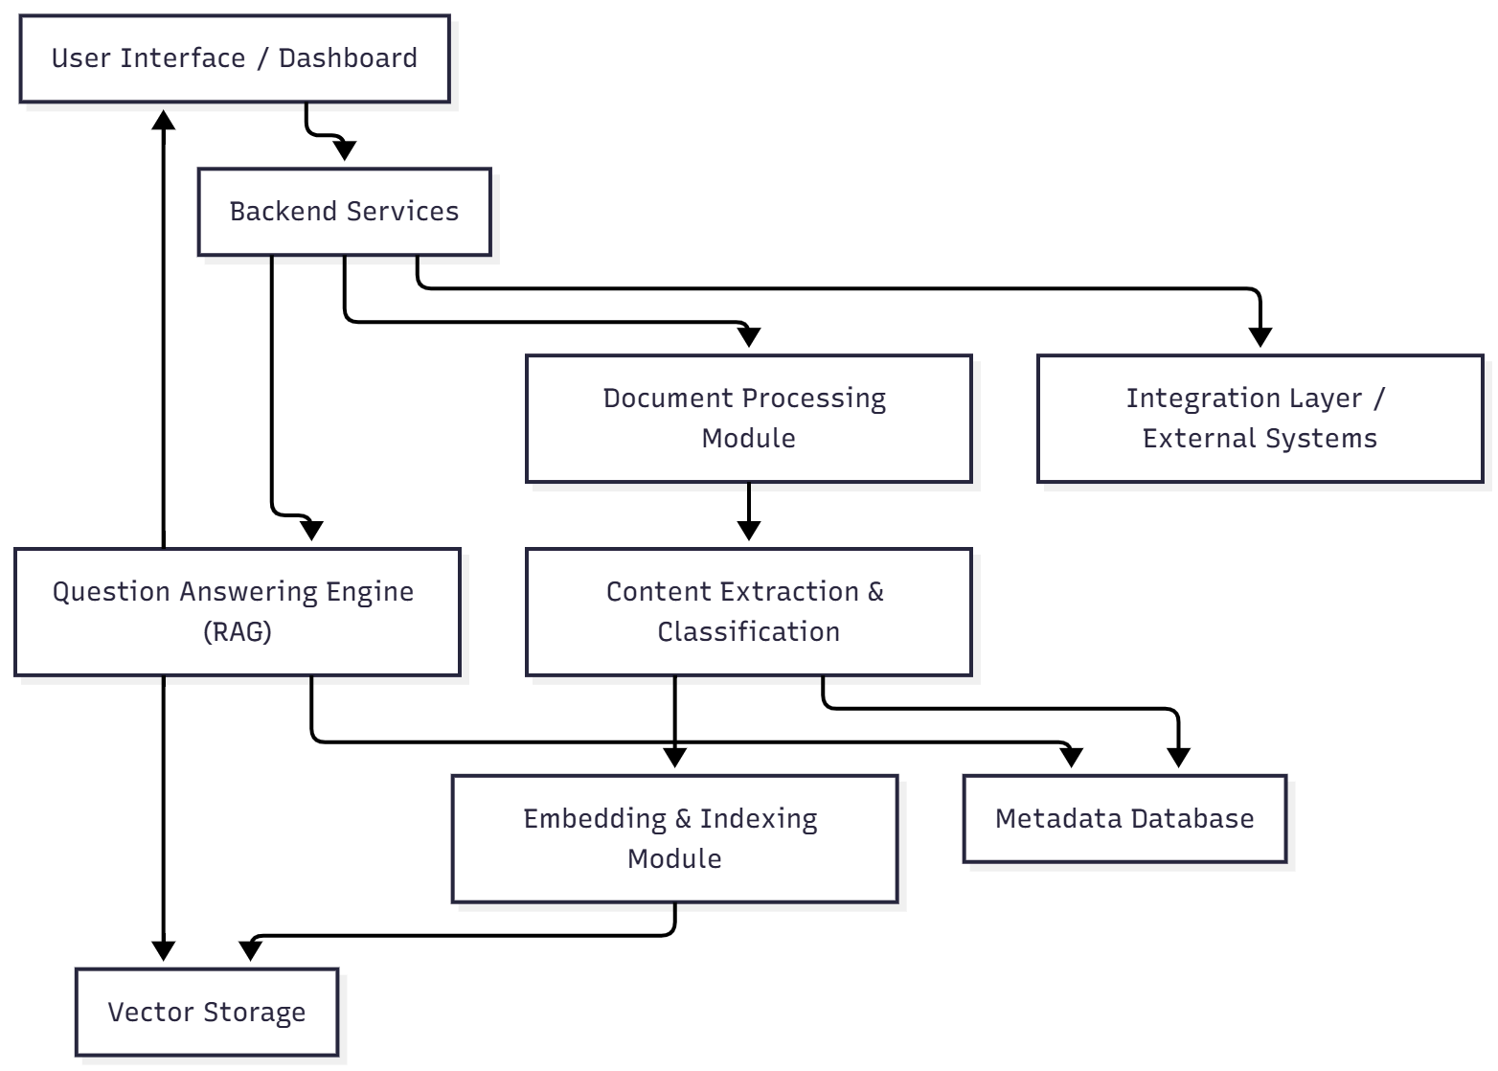

IMPLEMENTATION TOOLS AND TECHNIQUES

Implementation Methodology
The development will follow an incremental and modular approach, ensuring that each system component is independently developed, tested, and integrated.
The key stages include:
- Document Processing Pipeline:
Building modules for document upload, classification, text extraction, and metadata generation using OCR and NLP techniques.
- Knowledge Base Construction:
Generating vector embeddings from extracted text and storing them in a local vector storage system for semantic search and retrieval.
- Question Answering Engine:
Implementing a Retrieval-Augmented Generation (RAG) pipeline that retrieves relevant context from stored documents and generates natural language responses.
- API and Integration Layer:
Developing secure and well-defined APIs to connect the system with external tools, such as email workflows or document management systems.
- Frontend Interface:
Designing an intuitive web-based interface for document uploads, searches, and interactive question answering.
- Testing and Optimization:
Conducting functional and performance testing to ensure accuracy, efficiency, and scalability across document types.

Implementation Tools
To maintain flexibility, the project will use open-source or self-hosted technologies that can be replaced or upgraded easily. The tentative tools and frameworks include:
- Programming Language: Python (for backend logic, AI workflows, and API development)
- Web Framework: A lightweight backend framework such as FastAPI or Flask for API management
- Frontend: A modern JavaScript framework (React or Next.js) for the user interface
- Databases: Relational database for metadata and a vector database for embeddings and semantic retrieval
- AI & NLP Components: OCR library for text extraction, embedding models for vectorization, and a language model for the RAG pipeline
- Integration & Automation: Workflow tools like n8n or direct API endpoints for email or third-party system integration
- Deployment: On-premise or private cloud setup using containerization (e.g., Docker) to ensure scalability and security

Development Approach
- Version Control: The entire project will be managed using Git for version tracking and collaboration.
- Testing Framework: Automated testing will ensure each module performs as expected before integration.
- Documentation: All APIs, workflows, and modules will be documented to facilitate maintenance and future upgrades.

PROJECT PLAN

10.1. Division of Responsibilities
Team Member | Responsibilities
Zain Ul Hassan | Overall project lead responsible for system architecture, RAG pipeline development, model integration, and backend coordination. Manages codebase, ensures feature alignment, and handles final deployment and optimization.
Ezza Ansar | Focuses on document processing modules including OCR, document classification, and metadata extraction. Assists in generating and managing vector embeddings, contributes to retrieval optimization, and handles pre-processing workflows.
Amna Ikram | Designs and implements the frontend interface, integrates it with backend APIs, and ensures smooth user experience. Works on external API integration (e.g., email-to-upload workflows), handles testing.

10.2. Project Timeline
The total duration of the project is approximately 20 weeks, starting from November 1, 2025 and ending in March 2026.

Key Milestones
- Requirement Analysis & Literature Review
- System Design & Architecture Finalization
- Dataset Preparation & OCR/NLP Setup
- RAG Pipeline Development
- Backend API & Integration Layer
- Frontend Interface Development
- Testing & Optimization
- Final Documentation & Presentation
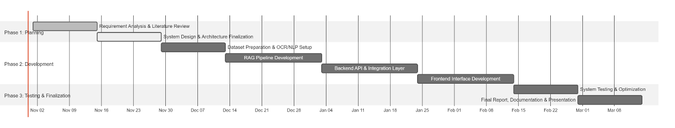

10.3. Project Management Approach
- Coordination: Weekly meetings to track milestones, update progress, and assign new tasks.
- Tools: Trello or Notion for project tracking, GitHub for version control, and shared Google Drive for documentation.
- Testing: Iterative testing after each module is developed.
- Supervision Reviews: Internal milestone presentations to ensure consistent progress.
- Documentation: Maintained in parallel with implementation for accuracy and clarity.

REFERENCES
- Google Cloud. (2024). Document AI Overview. Retrieved from https://cloud.google.com/document-ai
- Amazon Web Services. (2024). Amazon Textract – Extract Text and Data from Documents. Retrieved from https://aws.amazon.com/textract
- Microsoft Azure. (2024). Form Recognizer Documentation. Retrieved from https://azure.microsoft.com/en-us/products/form-recognizer
- LangChain. (2024). Building Applications with Retrieval-Augmented Generation (RAG). Retrieved from https://python.langchain.com
- Hugging Face. (2024). Document AI: Understanding Documents with Transformers. Retrieved from https://huggingface.co/blog/document-ai
- Hugging Face. (2024). Transformers and Large Language Models Documentation. Retrieved from https://huggingface.co/docs
- PyMuPDF Documentation. (2024). Working with PDFs in Python. Retrieved from https://pymupdf.readthedocs.io
- FAISS. (2024). Facebook AI Similarity Search Library. Retrieved from https://faiss.ai
- Tesseract OCR. (2024). Optical Character Recognition Engine. Retrieved from https://github.com/tesseract-ocr/tesseract

Supervisor’s Signature: ………………………
FYP Proposal Evaluation
(To be filled by students)
Write down the brief project topic and should not be confusing.
PROJECT TITLE:

STUDENT INFORMATION
Write down the detail of all group members in BLOCK LETTERS ONLY.
Sr. | Student ID | Name | Email | Mobile
1.
2.
3.

FOR EVALUATOR’S USE ONLY
Remarks: | ❑ Accepted  Accepted with Minor changes  Rejected
Suggested Improvements (if any):
________________________________________________________________________________________________________________________________________________________________________________________________________________________________________________________________________________________________________________________________________________________________________________________________________________________________________________________________________________________________________________________________________________________________________________________________________________________________________________________________________________________

Evaluated by:
Name: _______________________________________________________________________

Signature: _______________________________________________________________________
 | Day |  |  | Month |  |  | Year
DATE |  |  | – |  |  | –

